SaleCo_SQL

1. Import the SaleCo Database using the script located on iLearn.

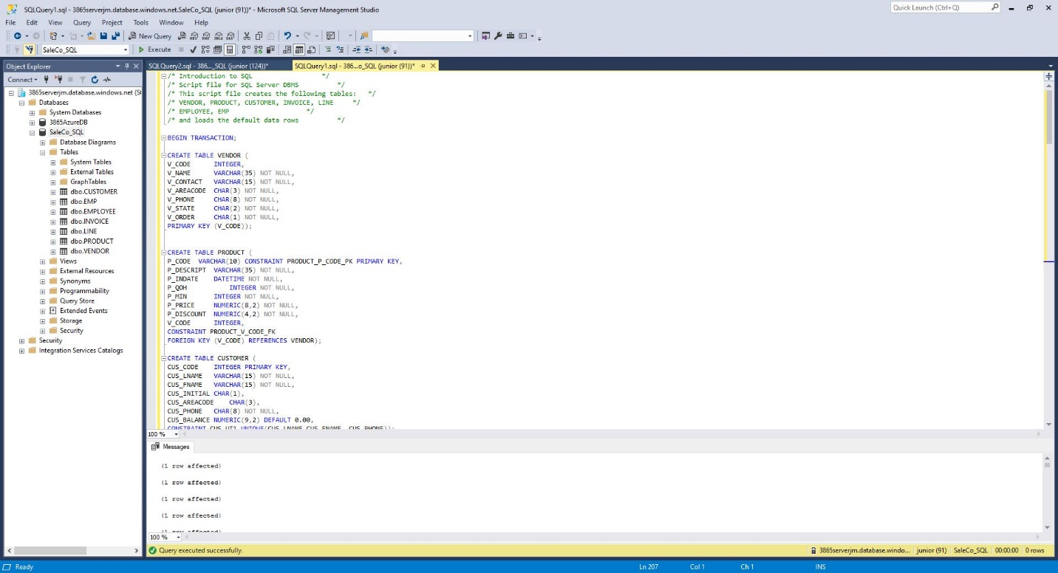

1. Write a query to count the number of invoices.

1. Write a query to count the number of customers with a balance of more than $500.

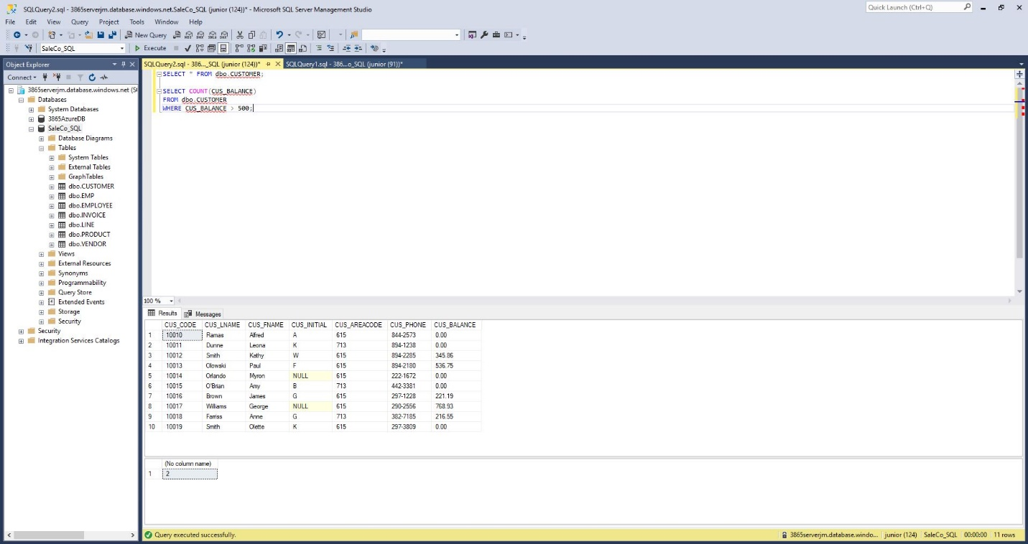

1. Generate a listing of all purchases made by the customers. Sort the results by customer code, invoice number, and product description.

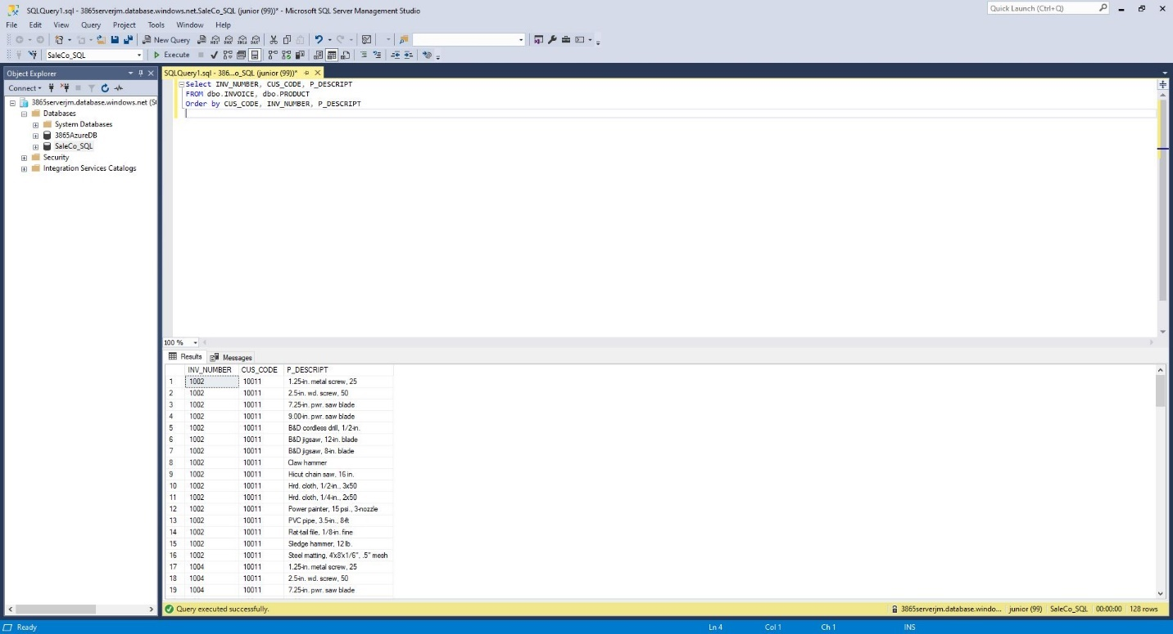

1. Use a query to show the invoices and invoice totals. Sort the results by customer code.

